Verify login with spaces

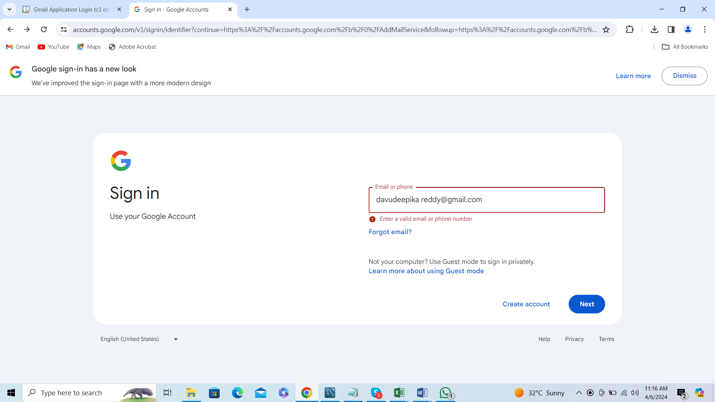

Error message is displayed